Project Development Phase Sprint-3

|  |  |
| --- | --- |
| Date | 30 October 2022 |
| Team id | PNT2022TMID33510 |
| Project Name | AI BASED DISCOURSE FOR BANKING INDUSTRY |

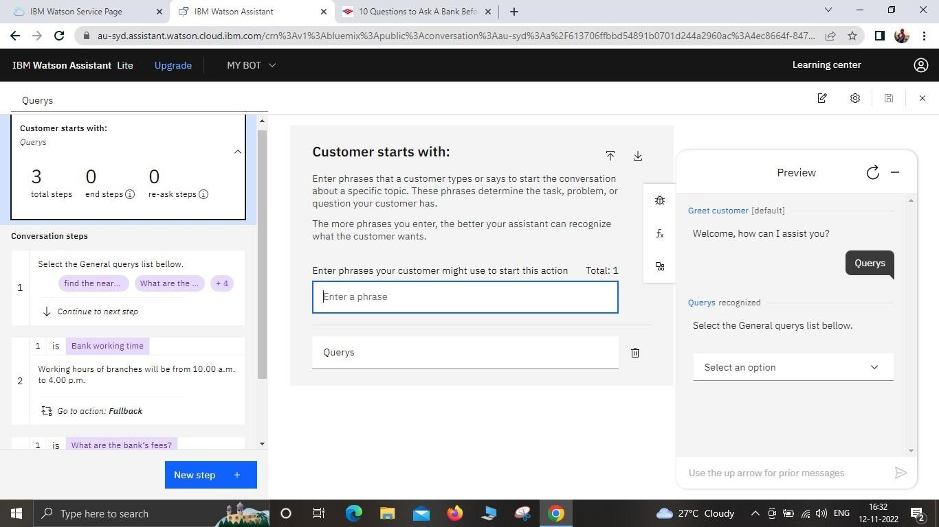Creating The General Query Action:

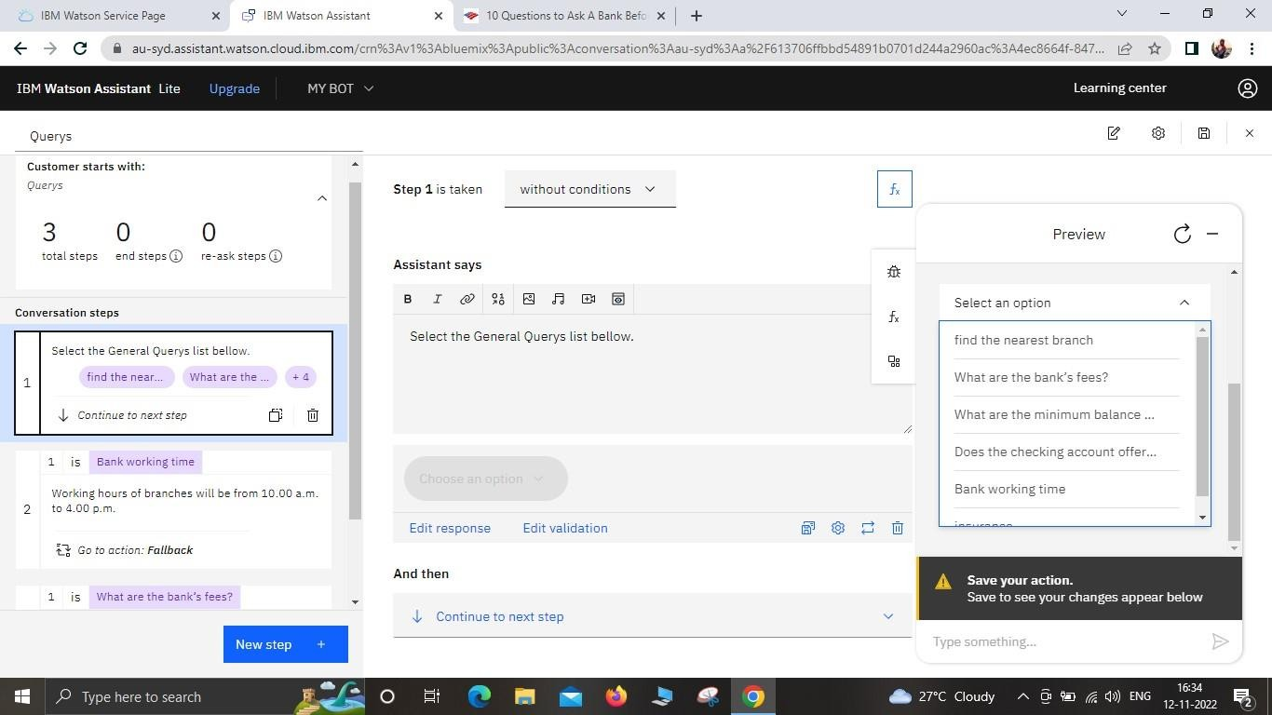

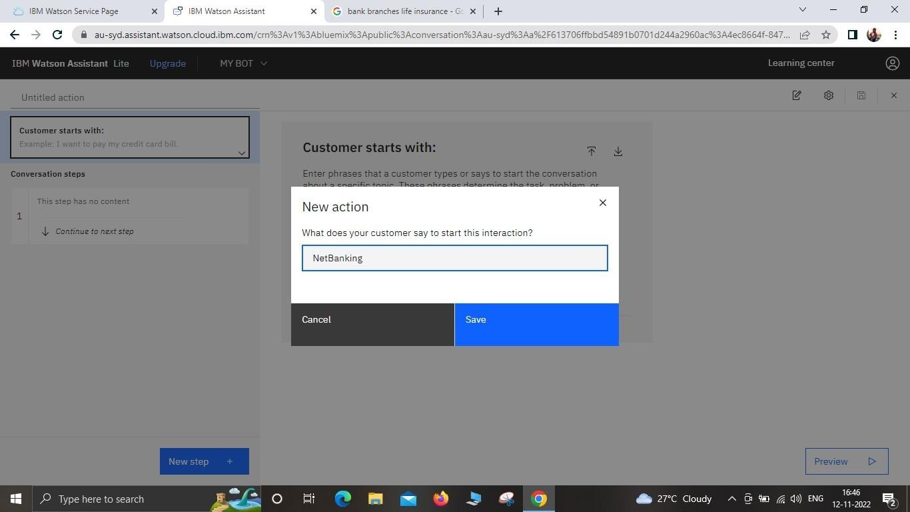Creating Net Banking Action:

